**Report and Analysis**

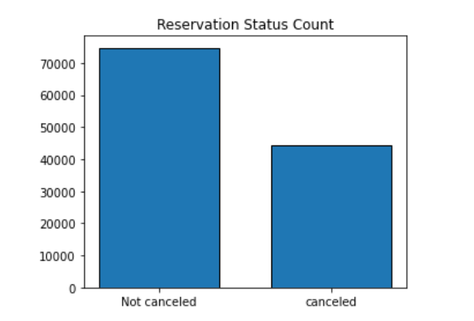

The accompanying bar chart shows the number of reservations that are cancelled and that are not cancelled. The following chart depicts that the reservation for City Hotel is higher than the Resort Hotel, but the rate of cancellation for the city hotel is 41%, which has a significant impact on the hotel revenue.

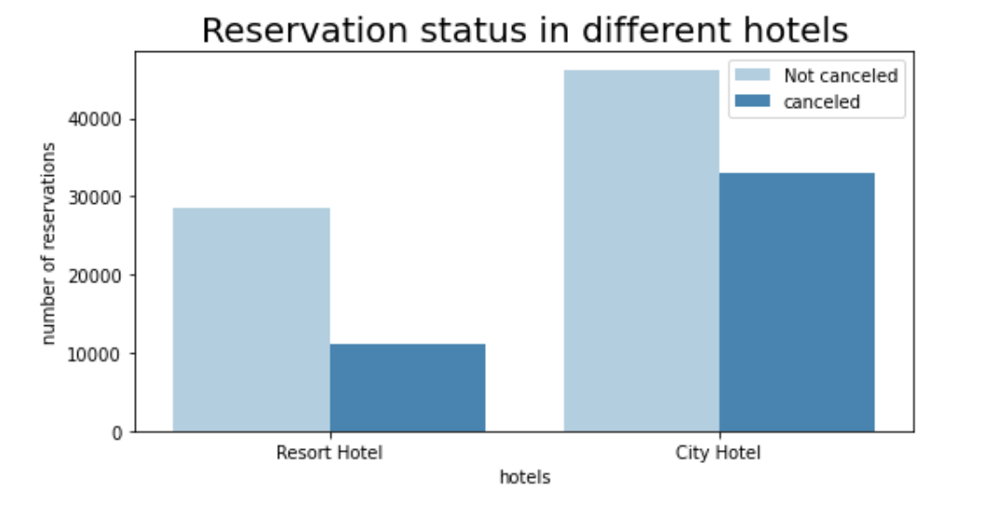

Below average daily chart shows that the price of Resort Hotel is higher than the City Hotel, that is why the number of reservations is less than the city hotel. So, the price of hotel has huge effect on no of reservations. Specially on weekends and holidays, there is spike in price of Resort Hotels.

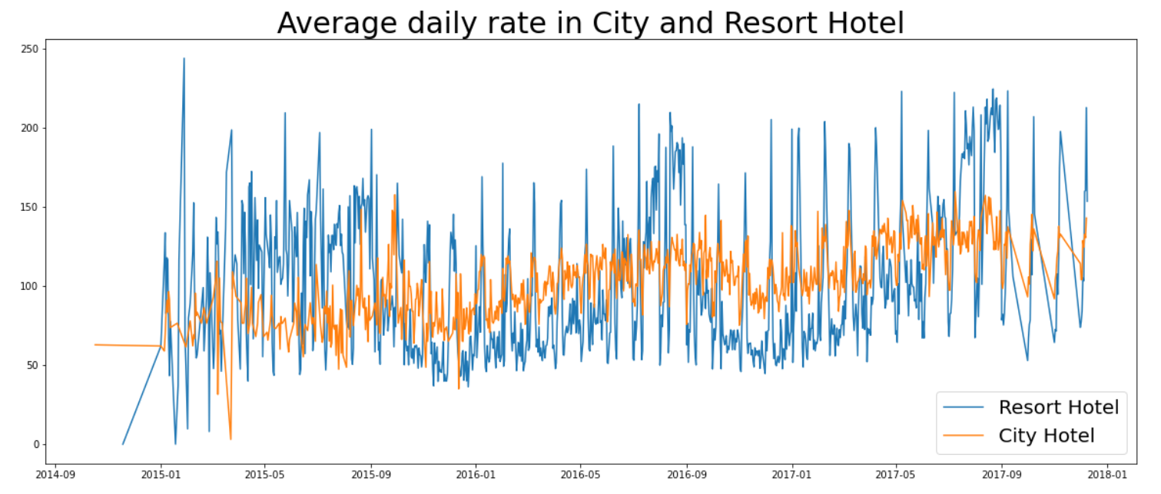

The below grouped bar graph shows the no of reservations by month. This shows that the higher reservations were done in the month of August and the maximum cancellation was done in January. It may be due to spike of prices during the month of January due to Holiday.

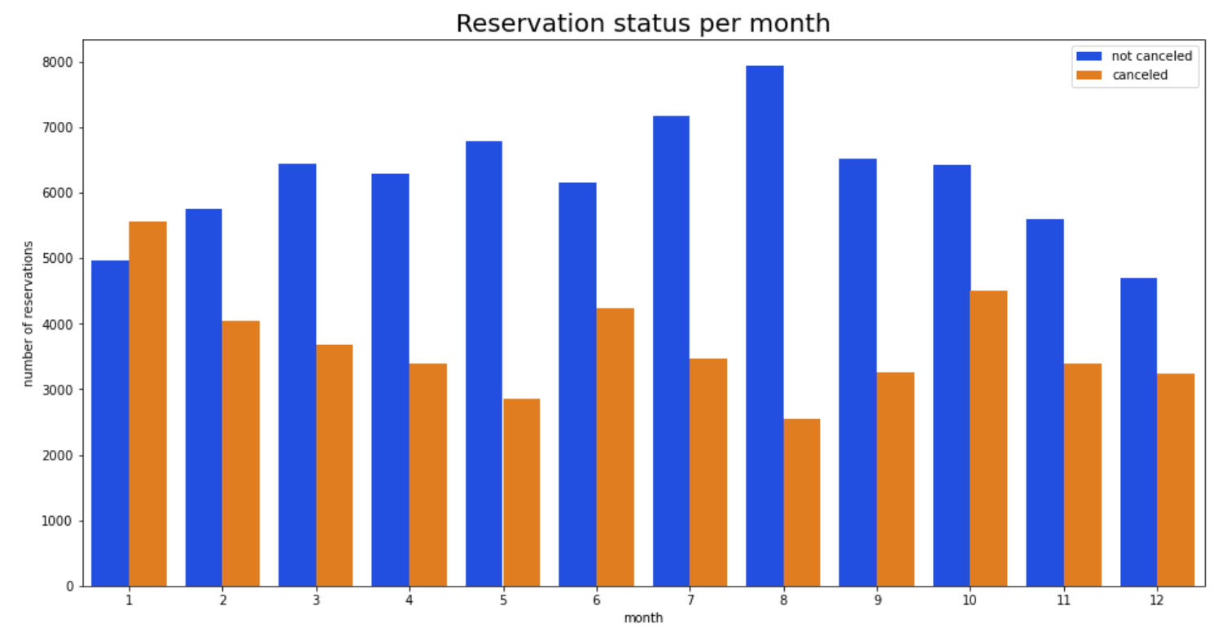

The below developed bar chart confirms that the cancellations are the most when the prices were higher (during the month of Jan) and there was least cancellation when the prices were lowest (during August). This concludes that the cost of accommodation is solely responsible for the cancellation.

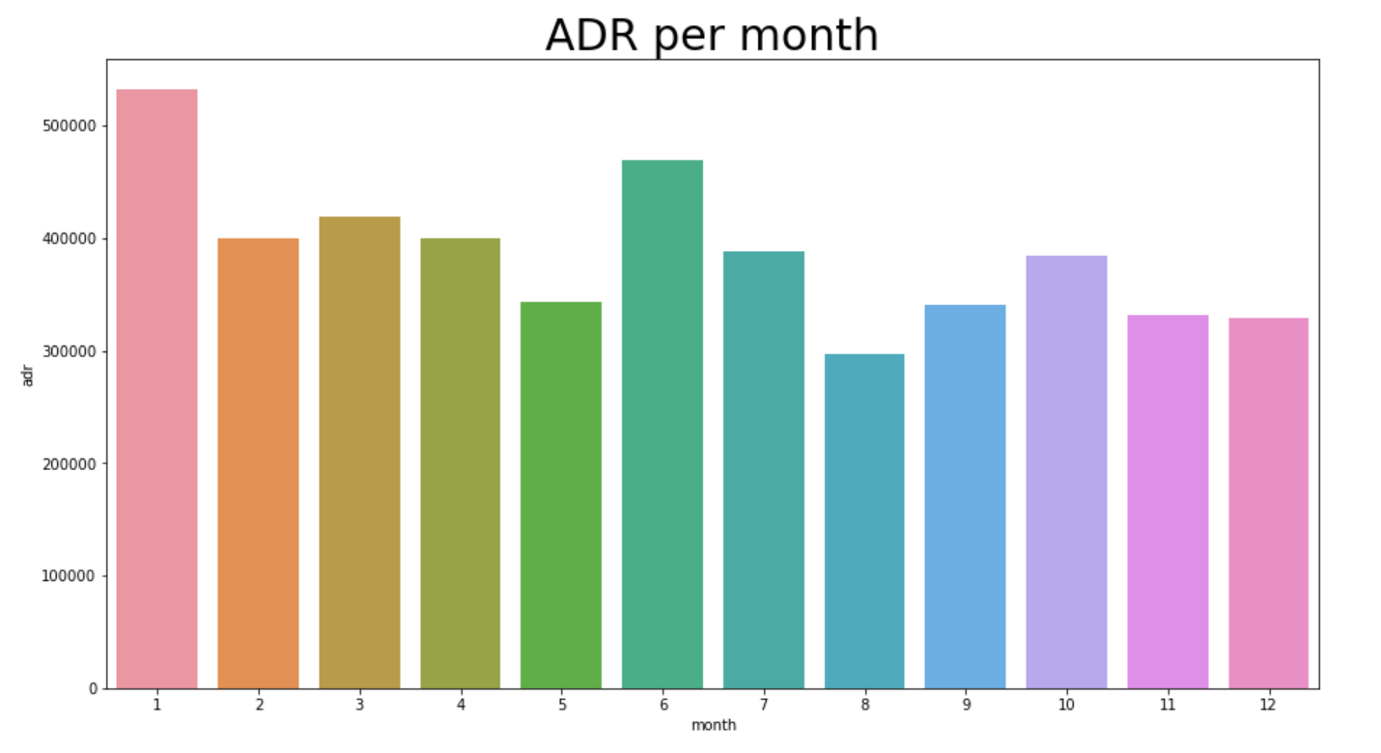

Now, lets see which country has the highest reservation cancelled. Portugal country is with the highest cancellation rate.

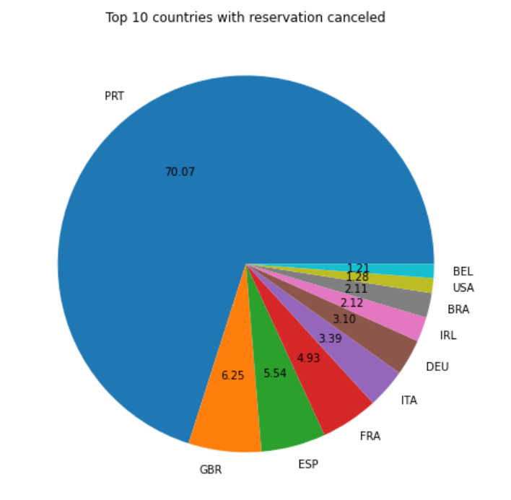

Let’s check the area from where the guests are visiting hotels and making reservation. Most of the reservations were made through online agent (around 46%). 27% were made from group. And only 4% from direct hotel.

As seen in the below graph, reservations are cancelled when the average daily rate is higher than when it is not cancelled. This clearly proves all the above analysis, that the higher rate leads to higher cancellation.

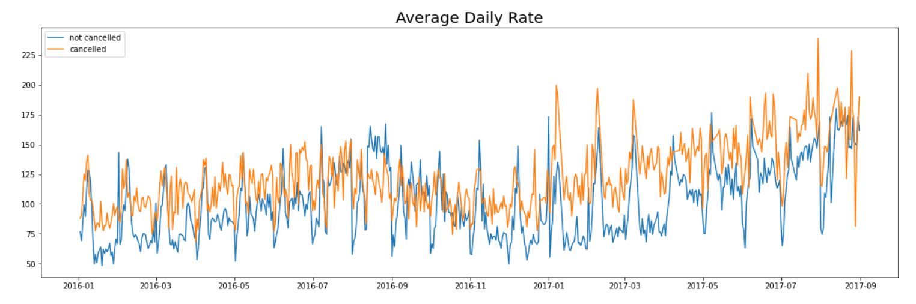

**Suggestions:**

1. Cancellations rate were higher when the price of the hotels was high. Hotels can work on there pricing based on their locations. They can also provide coupons for customers for their first booking.
2. Thay can also increase quality of their hotels and services mainly in the Portugal to reduce the cancellation rate.